|  |
| --- |
| Google Analytics |
| NAME: MUSKAN MATHIUR  COURSE: BBA (ANALYTICS AND BIG DATA)  SAP ID: 500093158 |

Google site link:

<https://sites.google.com/view/abc-maths-classes/home>

Google analytics is a platform which was originally originates from a wed analytics firm, urchin and was acquire by google in late 2005.

Google analytics is a great platform, where one can see their website’s performance. One can discover from which source, a large number of traffic are coming from and can put their efforts accordingly.

* I have made a website which is linked to google analytics under the account name, muskan mathur and the name of the property (google analytics offer to either track the website or the apps) named ABC Classes.
* The first page that we can see, is the home page. A home page is basically depicting the summary of repot. It mentions things like, what are the number of users we have, from which country they belong, what number of users have visited what pages, what feature of report you have recently accessed, etc.

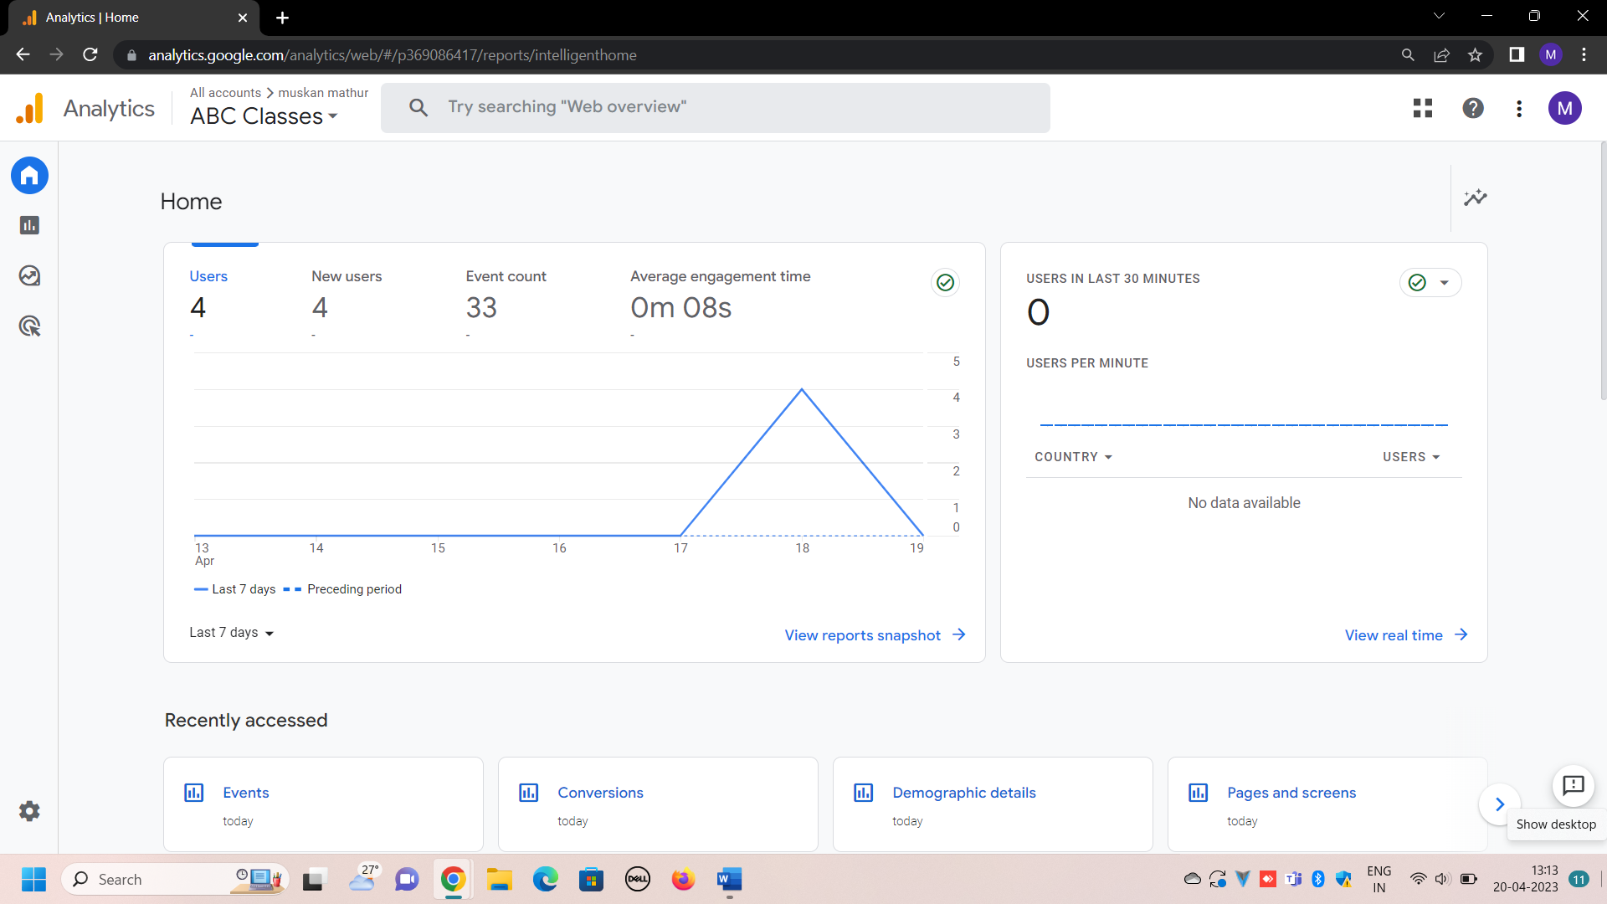

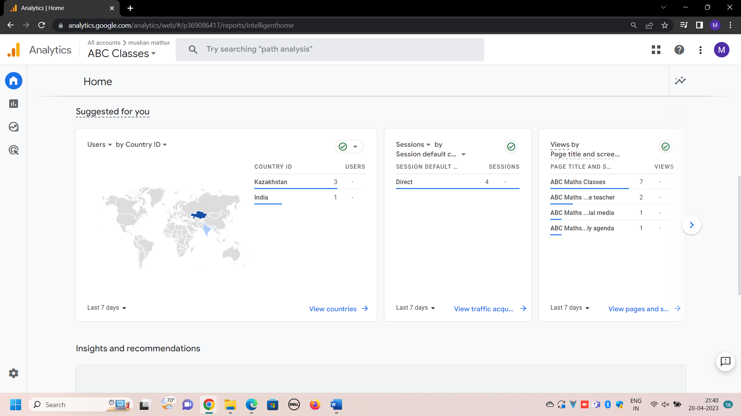

Report snapshot: it gives the overview of the report. It gives a short Information about the user, new users, average engagement time (which tell about the average amount of time someone spends with our web page), their location, event time, number of conversions and through which source they have come from.

All these things are mentioned in detail in the later part of this report.

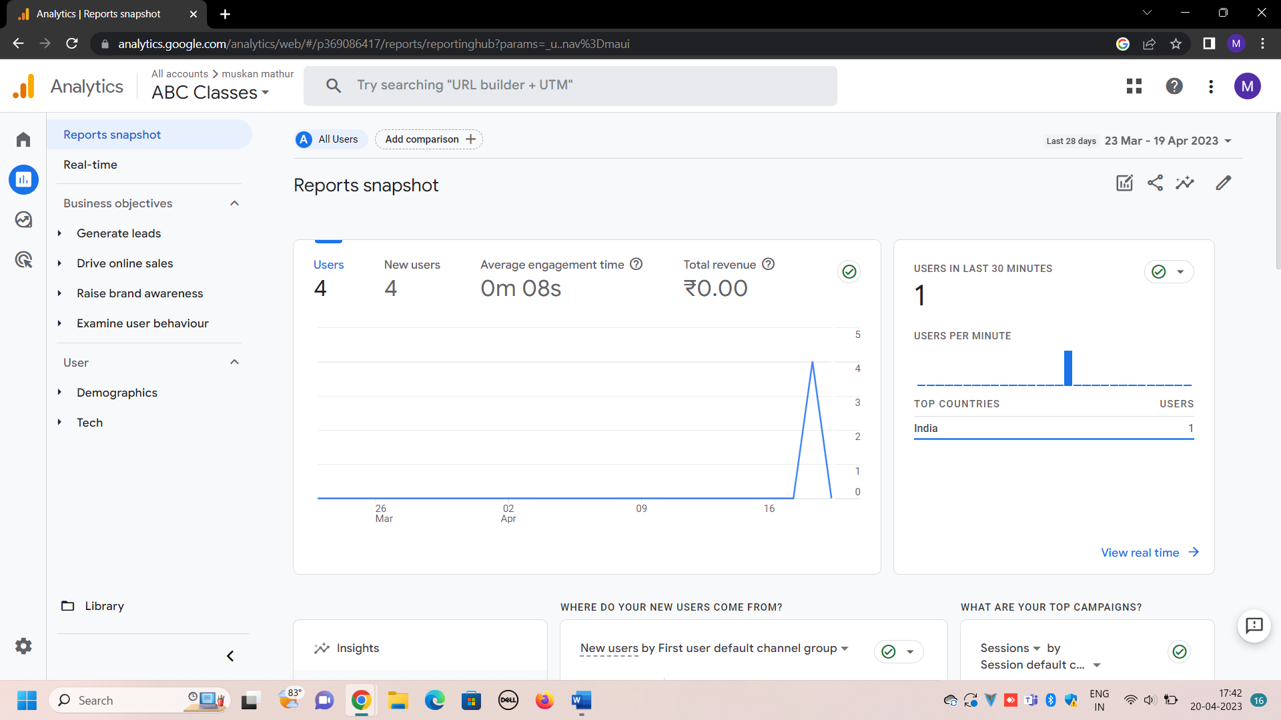

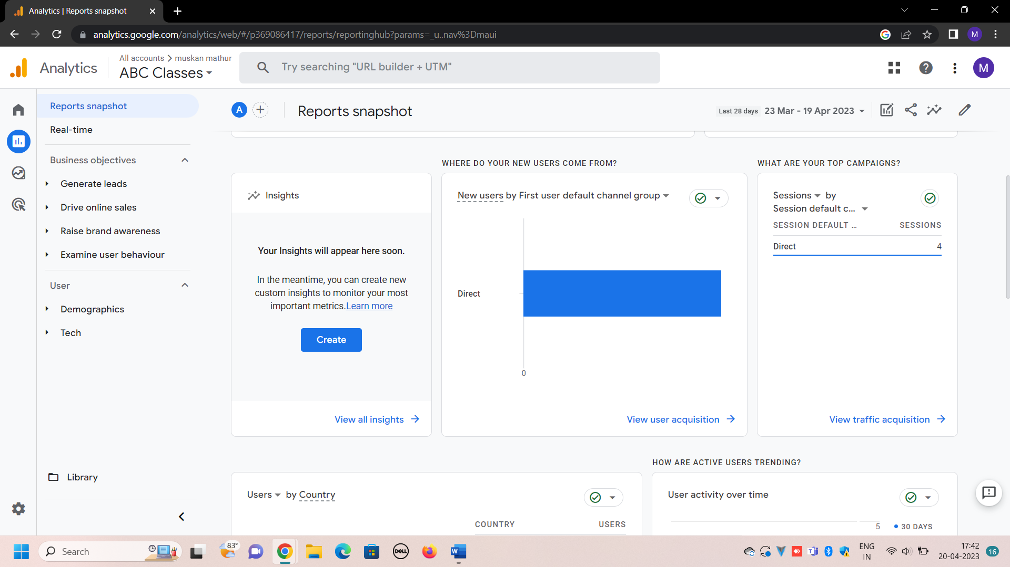

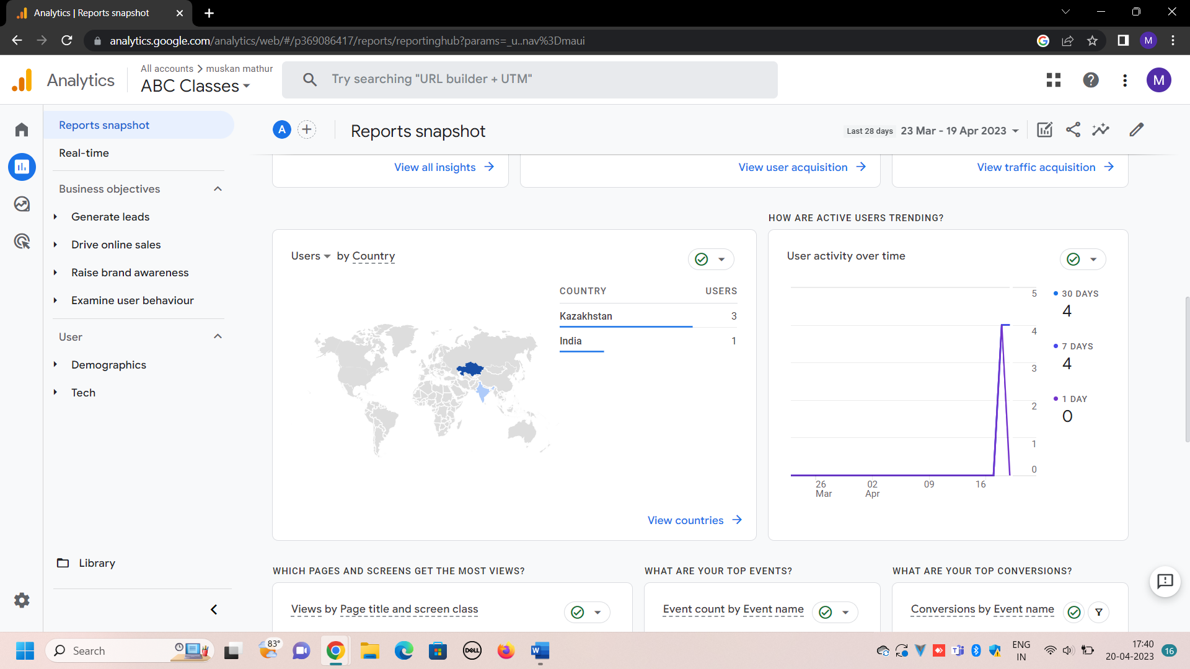

Real time: all the real time data about the users are mentioned here, which the details about the users by the sources, by event name, by page and screen who visited in last 30 minutes.

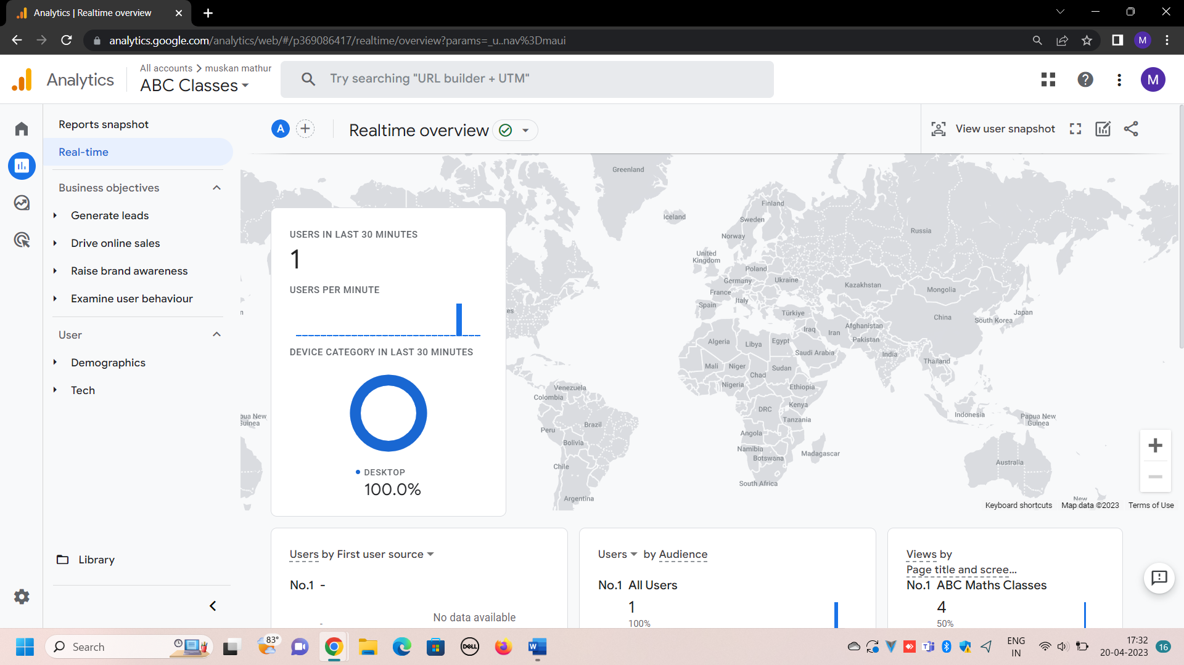

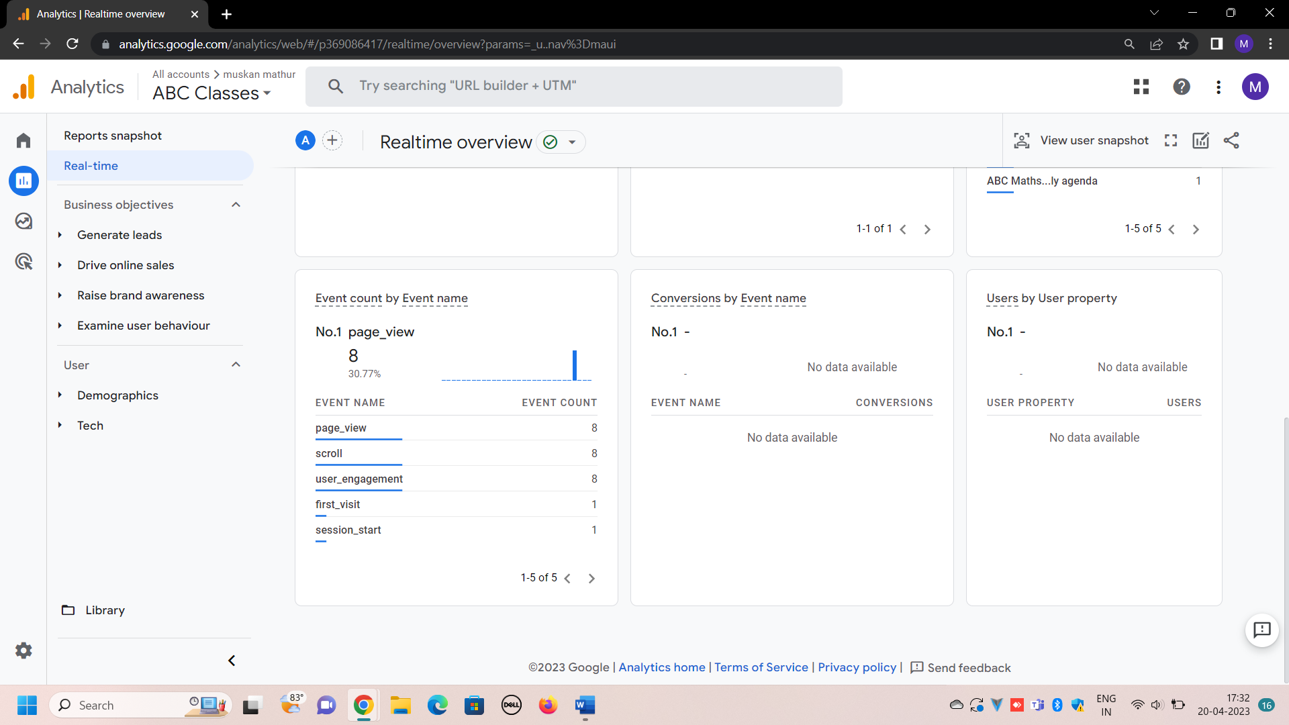

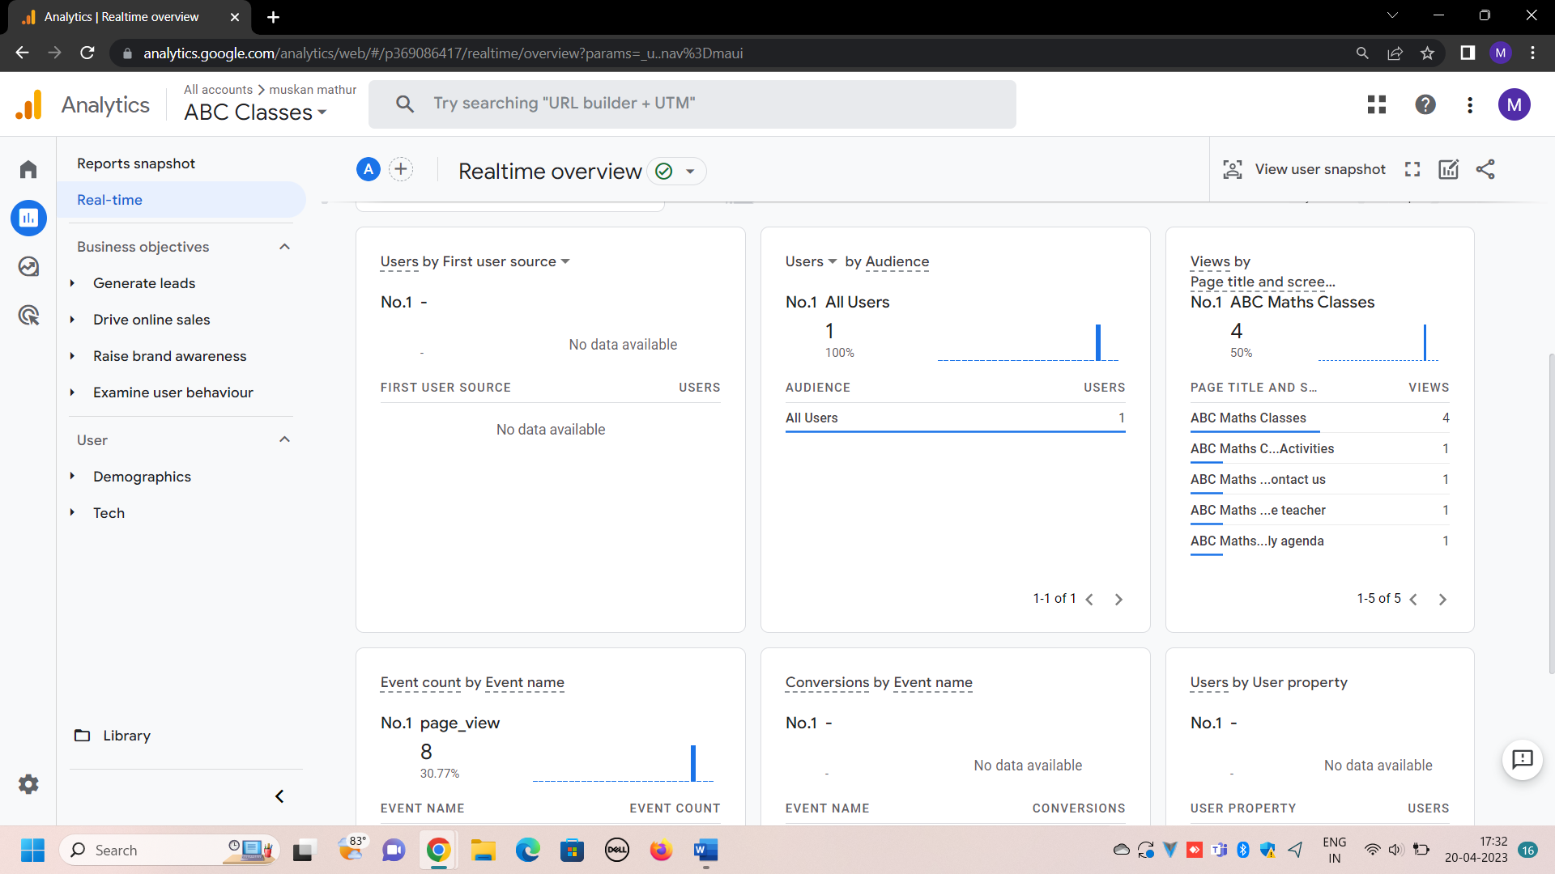

* According to the objective we have set during linking the website to google analytics, it will be detailed in the report section and they are:

1. Generate leads: under this objective, there comes various features. For example

User acquisition:

Under this feature, we get the detail information about how the users have accessed or find your website.

There are different sources through which a user can find the website. For example, a user’s or traffic can arrive through paid or unpaid searches, traffic can be arrived from the google ads or through email marketing campaigns. There is another type of source that is direct, which means the traffic have arrive by directly typing your URL or opening the website link. In my website, all the users have come from direct source.

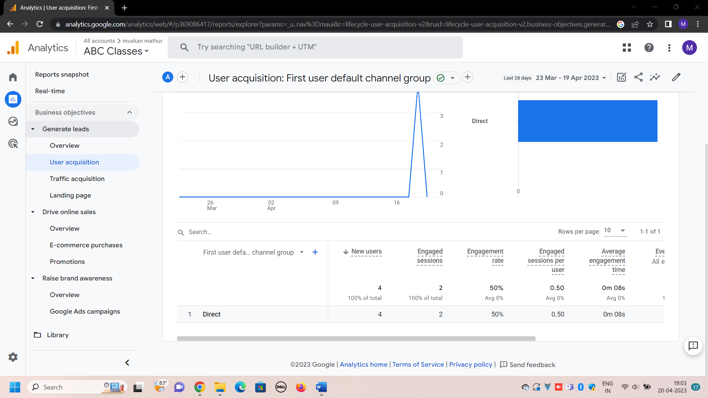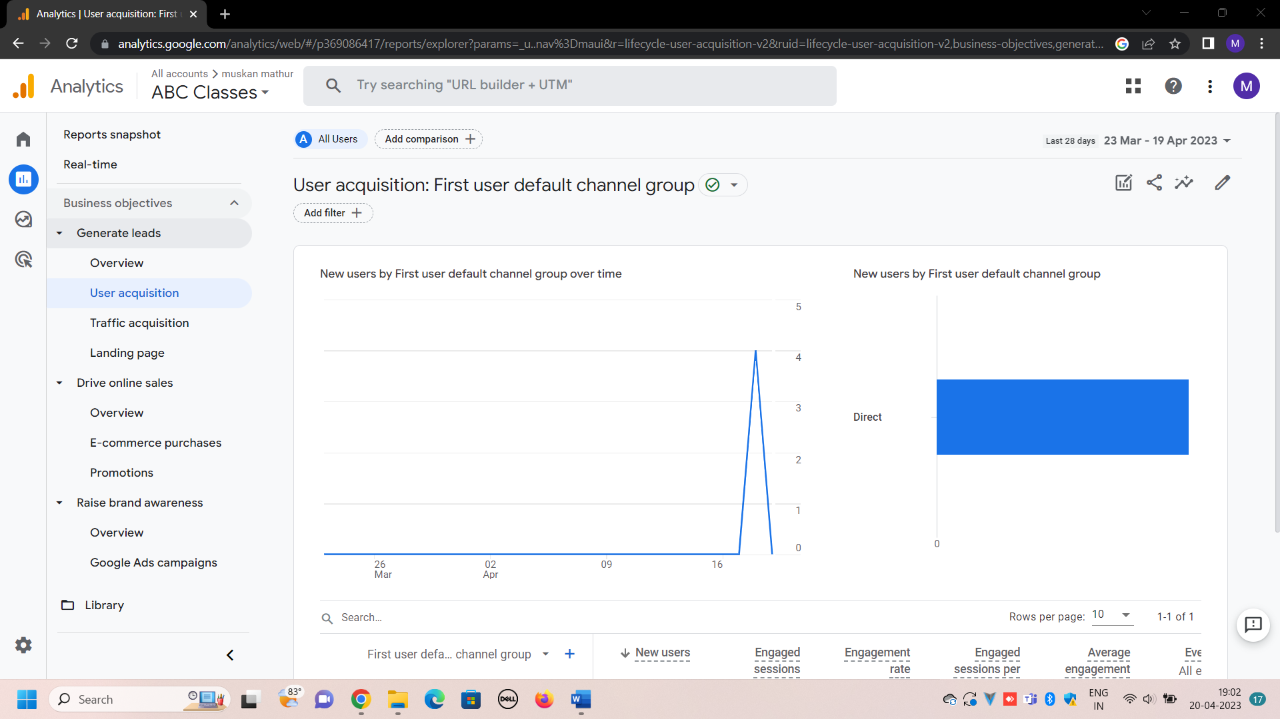

Here, the information is given about the engaged session. In this case this is 2, which means that there are two users who have last longer than 10 seconds or either they have gone two 2 pageviews engagement rate (which basically shows the percentage of engaged sessions), per user engaged session, on an average, user have been in the website for 8 seconds.

Traffic acquisition: traffic acquisition feature show from where the traffic has come from. The only difference between the user and traffic acquisition is that that user acquisition considers only new users while traffic considers both, the new as well as the returning. It includes the engagement of users based on sessions. (Session is a group of user interactions with your website that take place within a given time frame.) Both the feature shows the number of users, their sources along with the date and time.

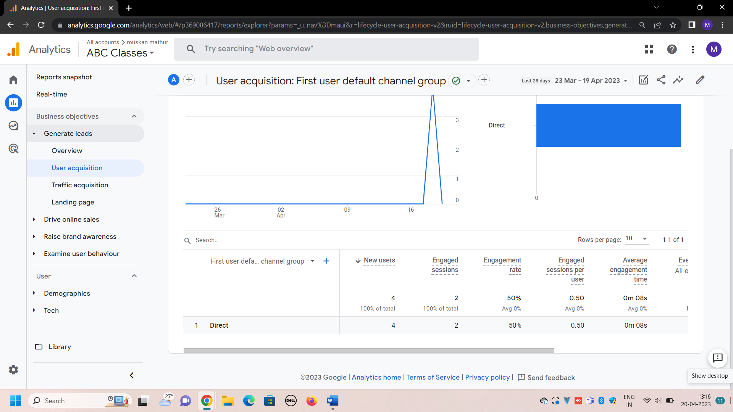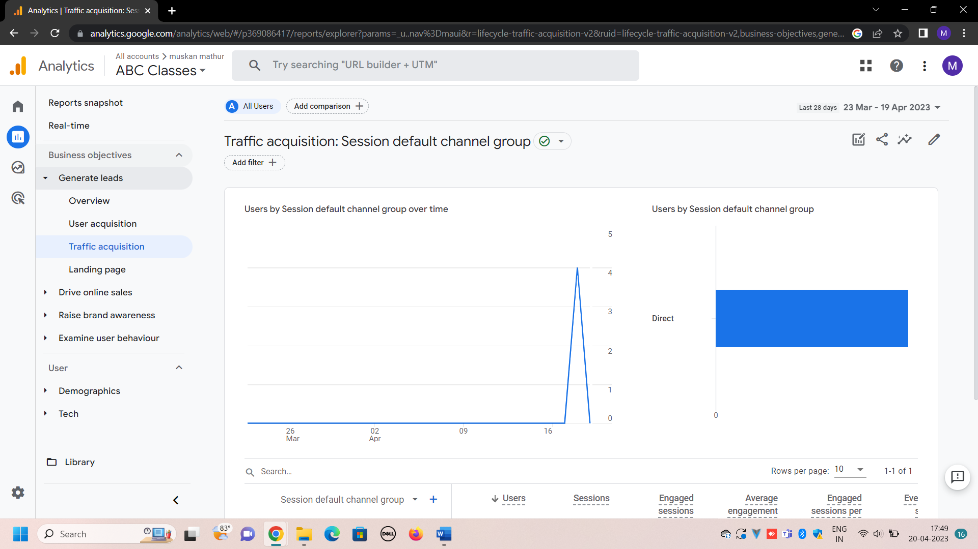**.**

**The landing page** report talks about the first page a user has land while visiting the website, it also gives information about what user have land in how many pages or we can say that it tells which page have been visited by how many users. As there were 4 users, 4 sessions have been created.

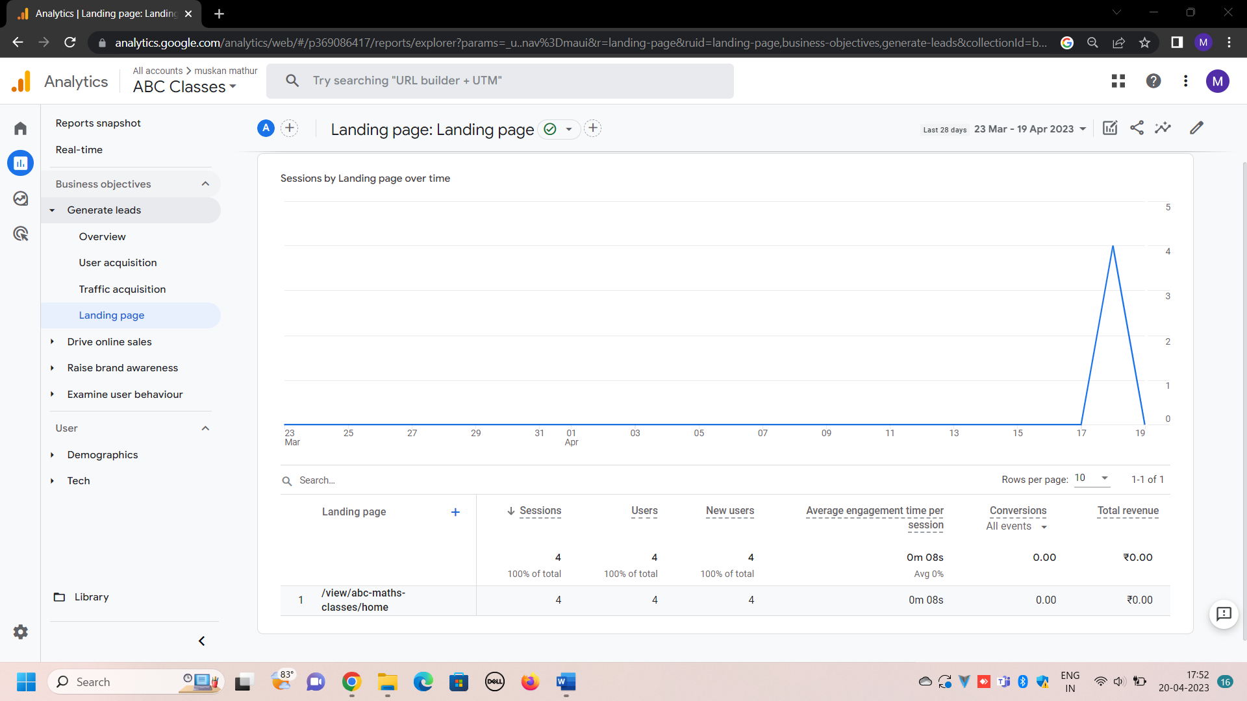

1. There is a report **drive online sales**, under which reports like ecommerce purchase (which shows information about the products or services you sell on your ecommerce store, the number of items viewed, items that are added to cart) all are mentioned
2. There is another component or objective**, raise brand awareness** which have reports like:-

**Google ads campaigns**- which tell how much traffic are came through your Google Ads campaigns. We can know whether the Google Ads campaigns are meeting the expectations.

**Demographic detail** is another report which tell about from where our users belong to. It represents the information using graphs. It tells the users by country, so we can check from where most of our traffic come from. It also includes information like, engagement rate, engagement sessions, average engagement time, etc. here, I have 4 users and out of this 3 users are from kazakhstan.

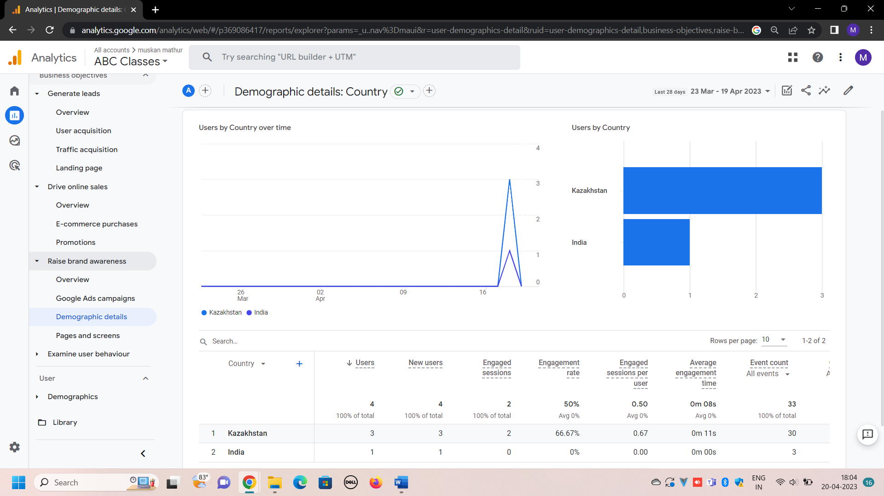

Page and screen: This report tabulates the information regarding the number of pages, a user has visited or more specifically it gives the data of what number of users or traffic have visited what number of pages along with how long they have engaged in this website. This information is also represented in the form of graphs as well, which include the time frame concept as well.

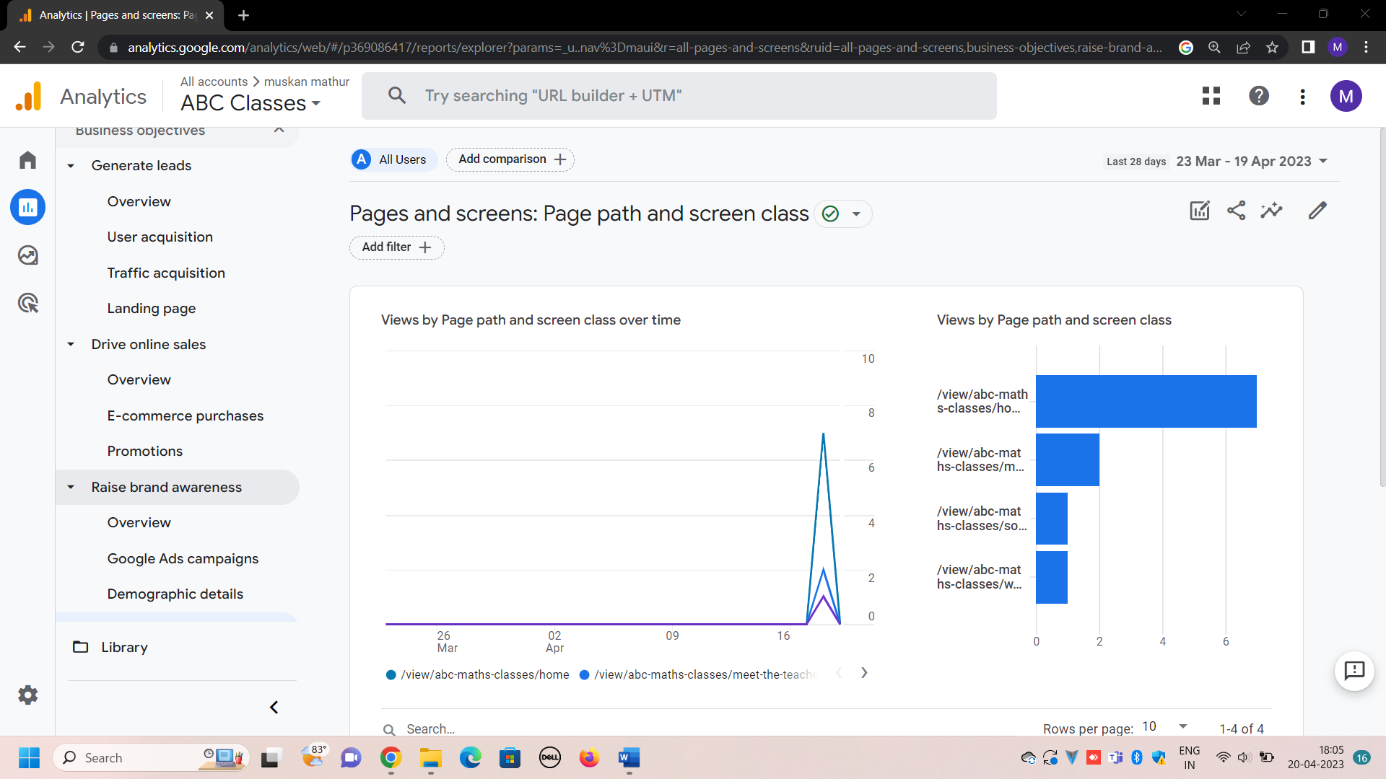

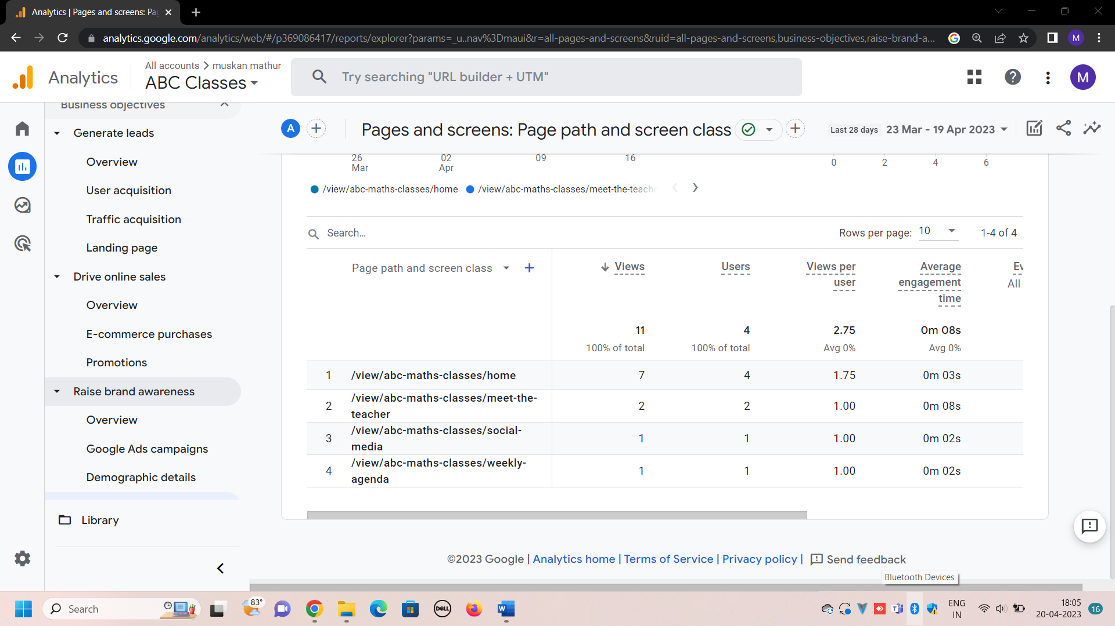

1. **Examine user behavior**: under this events and conversion’s details are mentioned

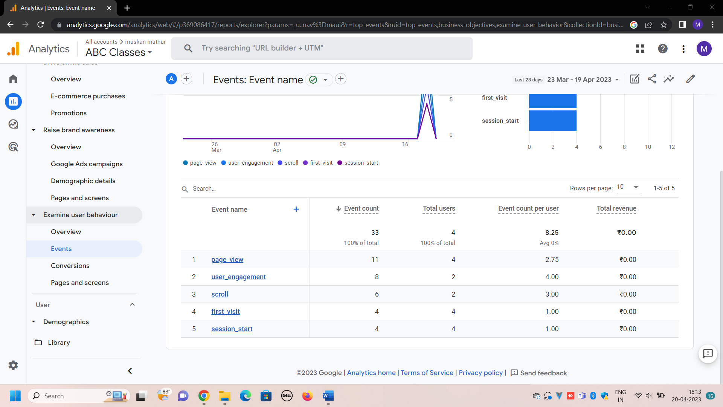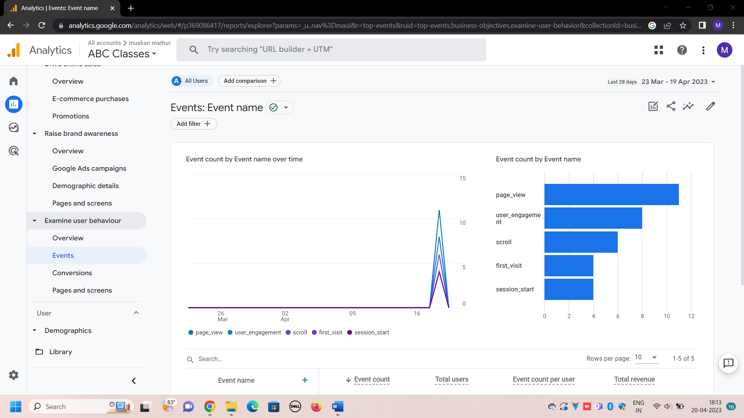**Event:** it allows to measure a specific interaction or occurrence on our website, it basically tells or measures that when a user have loaded the page or click a link or make a purchase.it give information about the count of event by their name, etc. for example there are 2 users who have scroll and the count is 6 times

**Conversion** is another report which give the information about those action that is valuable to us, like how likely a user will become our customer, it includes actions like, a user making a purchase

* There is another component, known as **users.** Under this, there are two reports: demographics details and tech

**Demographic report** basically displays the detail of country, about the gender, interest, language and age of users. Here 3 users are from kazhaksthan and 1 is from india. The town is also mentioned respectively. The language used is english.

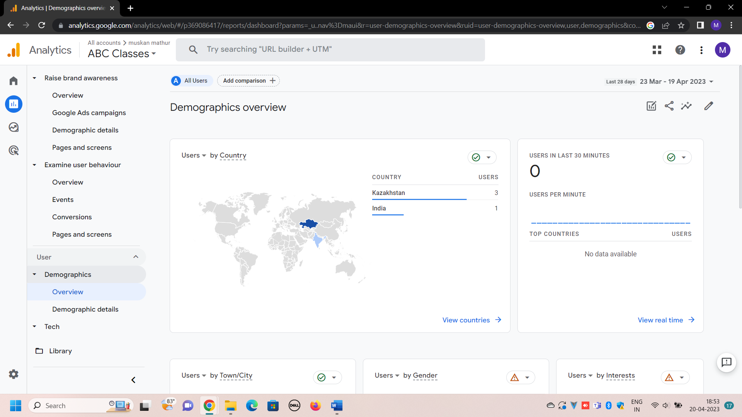

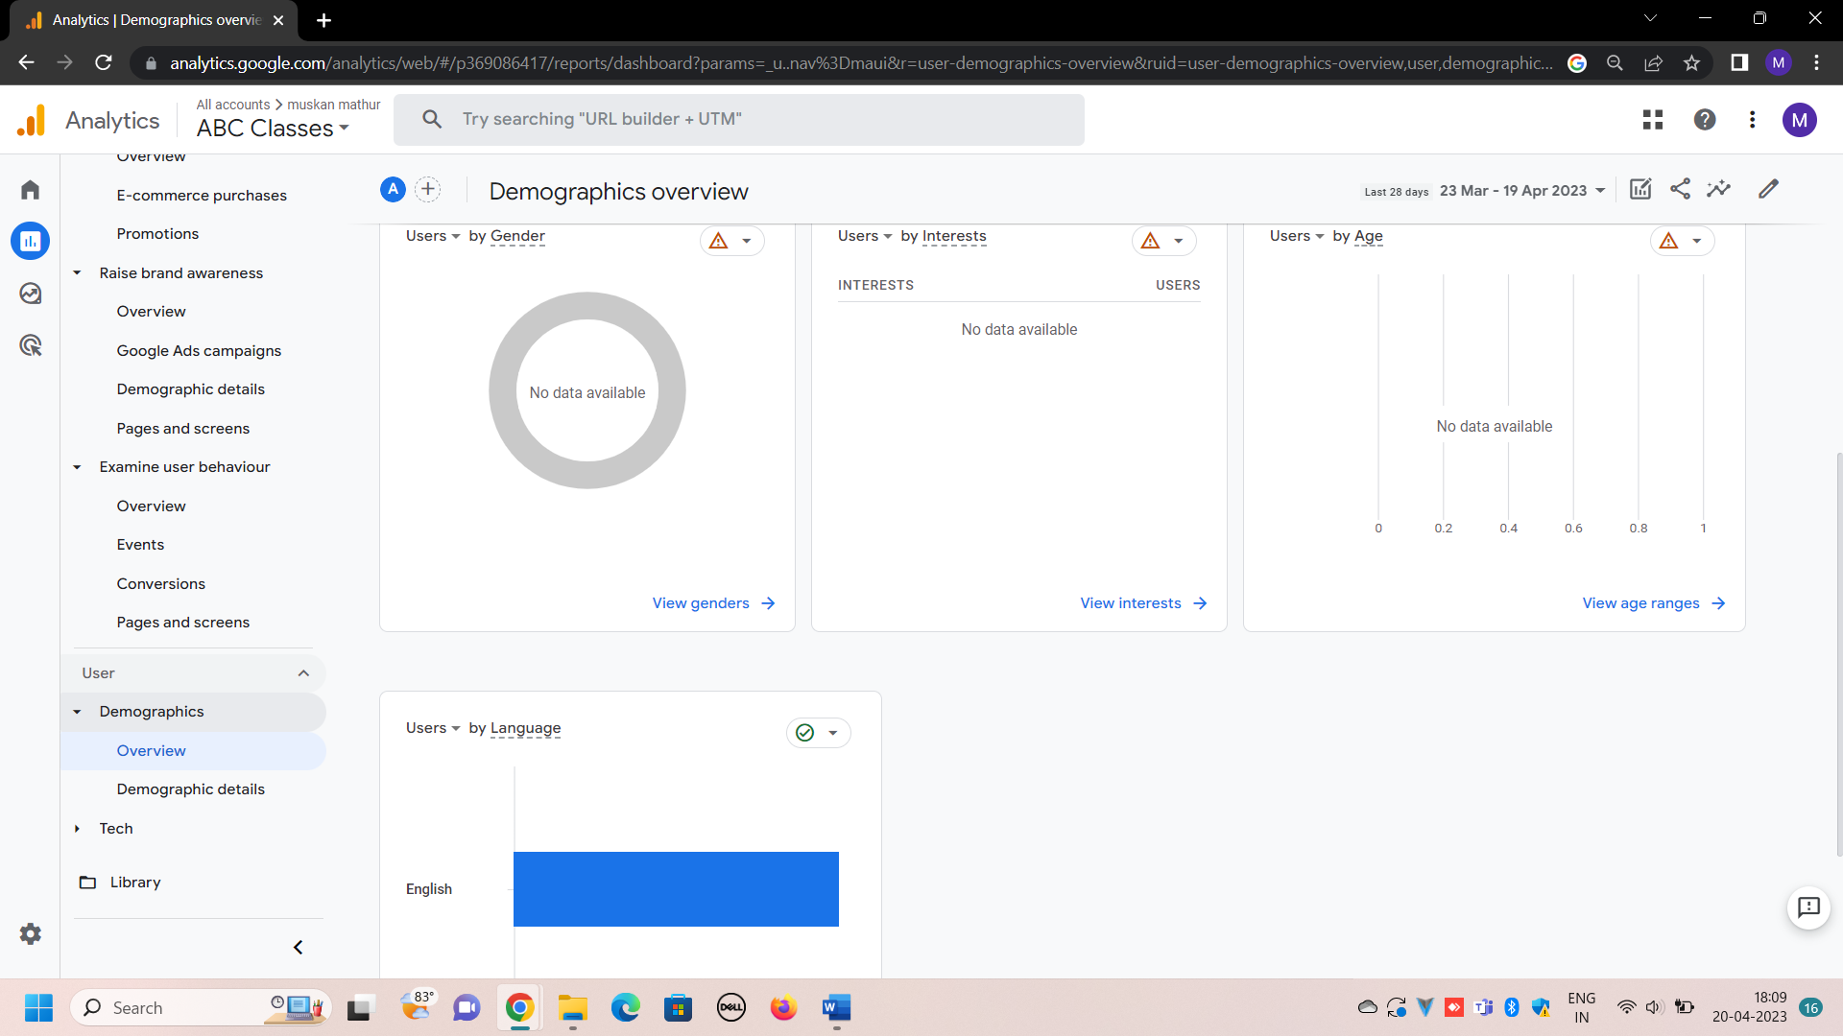

**Tech reports** the display the source of technology or what platform a user has used to visit the website. It even tells the information about the operating system as well as the app version.

Here, all the users have use chrome browser to open or to access the website.

